LIVE VIRTUAL EVENT E-BLAST GUIDE & TEMPLATE

E-Blast approval is required 24 hours in advance.
Please email E-Blast drafts for approval to:

Jon Brockett jbrockett@sagawards.org
Jen Coyne-Hoerle jench@sagawards.org
Sarah Barry sbarry@sagawards.org

You may send up to 2 national Event E-Blasts (per title) to Nom Comm members.
Each national event is allowed 1 Reminder Nom Comm E-Blast.

Formatting
- Live Virtual Event E-Blast Invitations and Reminders must be submitted as Word .doc files. PDFs will not be accepted.
- Up to 2 images or graphics may be included on each blast. We suggest title treatment and / or a one-sheet.
  - Title treatments must be .png and between 700 and 1000 px wide.
  - One-sheets and photos must be .png and between 1081px x 1600pm.

Language
- All E-Blasts must include “Paid For” text below:
  - NOT PAID FOR BY SAG-AFTRA – or – PAID FOR BY [STUDIO/COMPANY]
- Any reference to the Nominating Committee must be referred to as the “SAG Awards Nominating Committee” or “SAG Awards Nom Comm.” Please do not use just “SAG” or “SAG Nom Comm.”
.
- To avoid confusion, please do not refer to Q&A’s as “Conversations” unless in association with the SAG-AFTRA Foundation.

Details to Include
- Date / time / description of event (and how to access if applicable)
- Does the invitation extend to guests in the same space as the Nom Comm member?
- Digital Screener Access Information - Outline how members will be able to view the
film / program before the event:
  - Previously provided digital screener access
  - Screening Window
  - Virtual Screening - shown live before the Q&A
- RSVP link / email
- Invitations must include a contact email for members to cancel their RSVP if the need arises.
- Runtime
- Up to 2 reviewer’s quotes may be included.
- No more than 1 additional link may be included (trailer, awards site, etc).
- Additional Studio / Network Piracy and / or Viewing Guidelines if applicable.

RSVPs
- For any RSVP emails created specifically for our group, please do not use the term “SAG.” You may use “SAG Awards” or “SAG Awards Nom Comm.”
  - For example: TitleSAGAwards@studio.com.
- Similarly, when noting Nom Comm affiliation in RSVP webforms (drop-down menu, etc.), please use “SAG Awards” or “SAG Awards Nom Comm.”
- We suggest having 2 RSVP affiliation options - SAG Awards Nom Comm and SAG-AFTRA to differentiate between Nom Comm and general SAG-AFTRA members attending screenings.

Cancellations
- Invitations must include a contact email for members to cancel their RSVP if the need arises.

Confirmations
- Confirmations for RSVPs are required and must be sent to members via email 24 hours in advance of an event.
- Confirmations should include the following:
  - Link or access to view content - if applicable
  - Date and timing of event
    - If screening live, indicate start time of screening and start time of Q&A portion.
    - Will people be able to log into the event once it has started?
  - Login information
  - Technical support contact
  - Cancellation email
- Any members who RSVP after an event is filled must be notified that they are not confirmed to attend.

Fees
- $1,000 fee per national Event E-Blast.
- $200 fee per subsequent email. This can include 1 reminder E-Blast to the Nom Comm as well as emails sent to the SAG Awards RSVP group to fill a Nom Comm screening.
- These fees will be invoiced in early April once Awards season concludes.

TEMPLATE TO FOLLOW

You are invited to a special live screening (and Q&A) of
TITLE OR TITLE ART
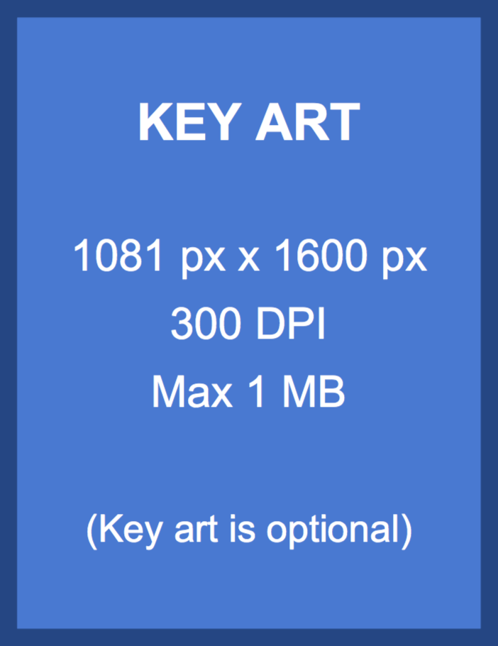

Event Day & Date
Event Time
Followed by a Live Q&A Discussion with
(List panelist names)

Event Type (Zoom, etc.)

Please RSVP to hyperlinked email address or link to web page

If you must cancel your RSVP, please email hyperlinked cancellation email address and include your name, screening title, event date, and time.

PLEASE ONLY RSVP IF YOU PLAN ON ATTENDING.
IF YOUR PLANS CHANGE, YOU MUST CANCEL YOUR RSVP USING THE CONFIRMATION EMAIL INSTRUCTIONS.

ABOUT TITLE
Description of title being screened.

RUNTIME

PLEASE BE PROMPT WHEN JOINING THE EVENT.

NOT PAID FOR BY SAG-AFTRA
– OR –
PAID FOR BY STUDIO / PRODUCTION COMPANY / NETWORK

Additional Studio / Network Piracy and / or Viewing Guidelines (if applicable)

SAG-AFTRA members and guests invited to events will behave in a professional and courteous manner. Any violation of the rules or transgression of decorum will be subject to review by the Awards Committee, which has authority to remove the member from present and future nominating committees, and to recommend that a member be brought up on disciplinary charges.

Screen Actors Guild Awards, LLC and SAG-AFTRA ("Parties") make no representation or warranty about any websites you may access to view FYC content or events. The parties have no control over the operation of the respective websites, nor over the use of disclosures of personal information you choose to share with them. Registration with and/or usage of such websites are subject to the respective sites. Information you choose to share with the entity will be used for purposes of providing the FYC content or event information.

