SAG Awards® E-Blast Guide & Template

Advanced approval is required on ALL MAILINGS AND EMAIL BLASTS
Please email E-Blast drafts for approval to:

Jon Brockett jbrockett@sagawards.org
Jen Coyne-Hoerle jench@sagawards.org
Sarah Barry sbarry@sagawards.org
John Bogulski jbogulski@sagawards.org

E-Blasts are available for event or screening invitations ONLY.
We do not allow general FYC emails or blasts with links to streaming content.

E-Blast Requirements
General
- E-blast requests require 24-hour advance notice.
- E-Blast invitations for booked dates must be sent 7-10 days prior to the event.
- E-Blasts are limited to 5 screenings per invitation.
- Screening schedules with 6 or more screenings must be mailed via US Post by our Union mailing house. See Mailings section for more information.

Formatting
- Invitations must be submitted as a Word .doc. PDFs will not be accepted.
- Up to 2 images or graphics may be included on each blast. We suggest title treatment or a one-sheet.
  - Images must be .png and between 700 and 1000 pixels wide.
- Up to 2 reviewer’s quotes may be included.
- Runtime must be included.

Language
- All E-Blasts must include “Paid For” text below:
  - NOT PAID FOR BY SAG-AFTRA – or – PAID FOR BY [STUDIO/COMPANY]
- All E-Blasts must include arrival text below:
  - PLEASE ARRIVE AT LEAST 45 MINUTES EARLY. SCREENINGS ARE OVERBOOKED TO COMPENSATE FOR NO-SHOWS. RSVPS DO NOT GUARANTEE SEATING. BRING YOUR SAG AWARDS NOM COMM CARD (or SAG-AFTRA ID CARD if not a Nom Comm screening) AND A PHOTO ID FOR ADMISSION.
- Any reference to the Nominating Committee must be referred to as the “SAG Awards Nominating Committee” or “SAG Awards Nom Comm”. Please do not use just “SAG” or “SAG Nom Comm”.
- To avoid confusion, please do not refer to Q&A’s as “Conversations” unless in association with the SAG-AFTRA Foundation.

RSVPs
- For any RSVP emails created specifically for our group, please do not use the term “SAG”. You may use “SAG Awards” or “SAG Awards Nom Comm”.
  - For example: TitleSAGAwards@studio.com.
- Similarly, when noting Nom Comm affiliation in RSVP webforms (drop-down menu, etc.), please use “SAG Awards” or “SAG Awards Nom Comm”.
- We suggest having 2 RSVP affiliation options - SAG Awards Nom Comm and SAG-AFTRA to differentiate between the Nom Comm and general SAG-AFTRA members attending screenings.

Confirmations, & Cancellations
- Invitations must include a contact email or phone number for members to cancel their RSVP if the need arises.
- Confirmations for RSVPs must be sent to members via email prior to the event.
- Any members who RSVP after an event is filled must be notified that they are not confirmed to attend.
TEMPLATE BELOW
SAG Awards® E-Blast Template

You and a guest are invited to a special screening of
TITLE OR TITLE ART
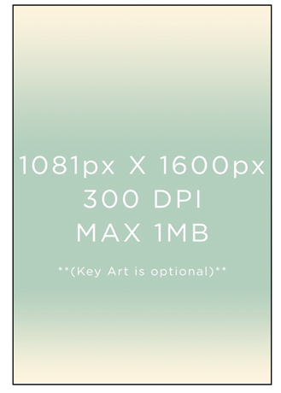
Event Day & Date
Event Time
Followed by a Q&A Discussion with
(List panelists as desired if applicable)

Event Location
(Name & Address)

Please RSVP to hyperlinked email address or link to web page

If you must cancel your RSVP, please call studio number or email hyperlinked cancellation email address (choose either or both) and include your name, screening title, date, and time.

About Title
Description of title being screened.

Runtime: minutes

PLEASE ARRIVE AT LEAST 45 MINUTES EARLY.
SCREENINGS ARE OVERBOOKED TO COMPENSATE FOR NO-SHOWS.
RSVPS DO NOT GUARANTEE SEATING.
YOU MUST BRING YOUR SAG AWARDS NOM COMM CARD (SAG-AFTRA MEMBER CARD if RSVP) AND PHOTO ID FOR ADMISSION.

NOT PAID FOR BY SAG-AFTRA
– OR –
PAID FOR BY STUDIO / PRODUCTION COMPANY / NETWORK

